## all subject demographics

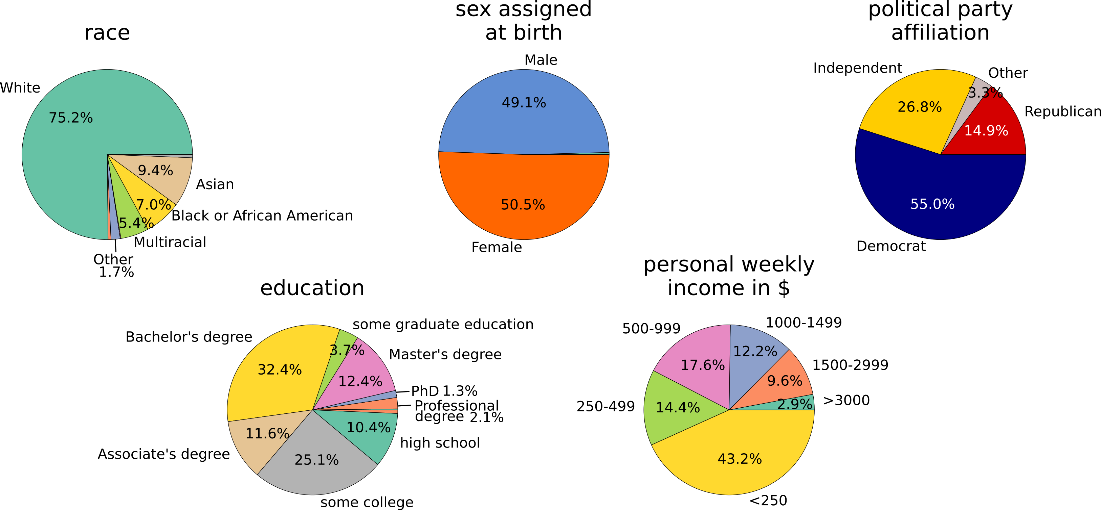

## all subject wave-by-wave counts

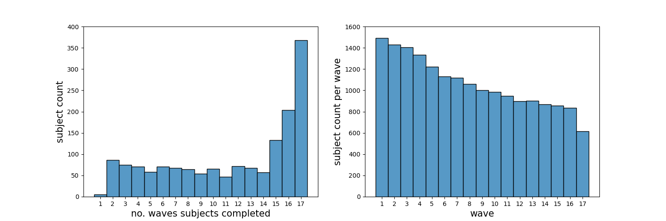

## all subject measure/attitude time courses



🡪 colored lines exemplary counties/subjects selected via maximum variation sampling on the first measure presented in each row, i.e., average Covid-case counts, mean social network health, and Covid concerns

## Between measures correlation (average within subject correlation over time) & withing subject standard deviation across time



Results & Conclusions:

1. collinearity between measures is relatively small, i.e., does not create a huge problem for multivariate regression models.
2. Within subject, across time variance of “importance of personal hygiene” is minimal (see also across-time plots of individual measures) 🡪 drop this attitude measure from regression analyses

## regression coefficients for significant regressors (rows) predicting attitudes (columns) separate by population density at participant location (countryside (left columns) vs. city (right columns)); non-significant nuisance regressors (race, sex, education) not shown

Results & Conclusions:

Similar findings for countryside and city

1. The most consistent predictors of Covid attitudes, both for people in the countryside and in the city, are participants’ personal restriction behavior (“personal behavior - restrictions”) and restrictions in the local environment🡪 the more they restrict their behavior/ the stronger the local restrictions, the higher their health concerns (local restrictions: countryside only), covid norm agreement, and attitudes towards public restrictions/ large gatherings.
2. Local Covid - numbers predict health concerns and norm agreement irrespective of population density
3. Local economic impacts (unemployment numbers) predict participants attitudes towards public restrictions: higher unemployment 🡪 higher agreement with restrictions.

Different findings for countryside and city

1. Political party affiliation predicts restriction attitudes in the countryside but not in the city 🡪 in the countryside Republicans and “Other” groups agree less with public restrictions and gathering Restrictions than Democrats
2. The health impact on the personal social network suggests a negative relation with public restriction attitudes in the city but a positive relation with respect to attitudes towards large gatherings in the countryside
3. Personal economic impact negatively predicts Covid health concerns in the city, i.e., a higher personal income suggests lower health concerns (potentially not specific to city vs. countryside but due to income differences in the country and in the city 🡪 more high income participants in the city than in the country, see supplemental demographic plots )

# Supplemental Material

## Countryside

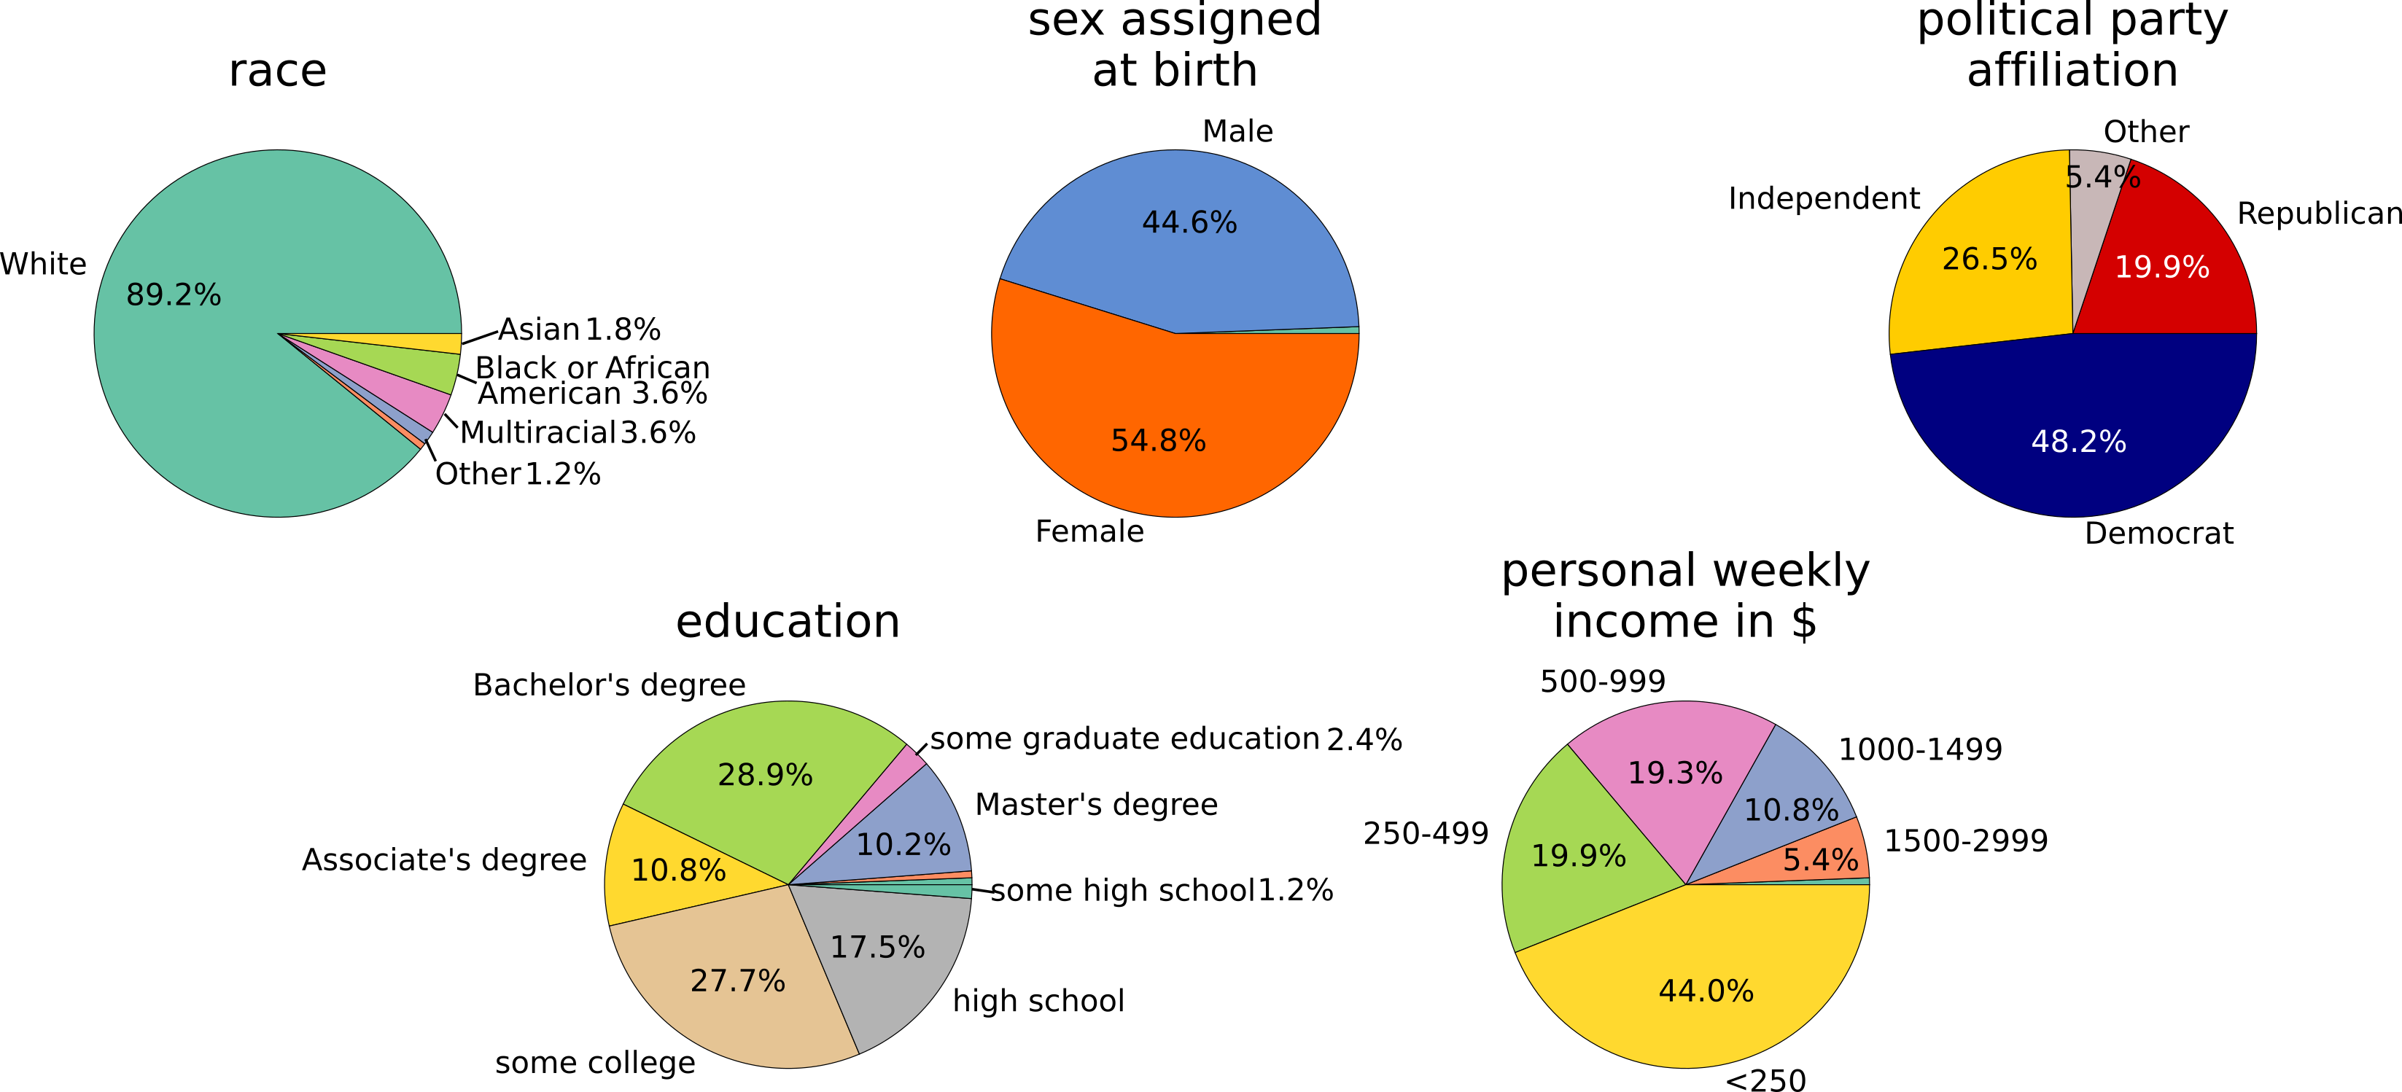

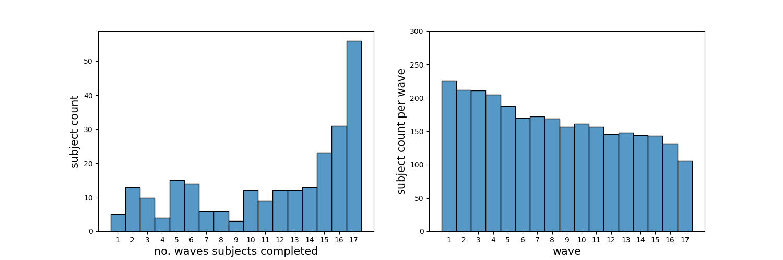

## City

